**SOURCE FOUR** – Photographs, Howard Carter’s discovery of Tutankhamun’s tomb 1922CE

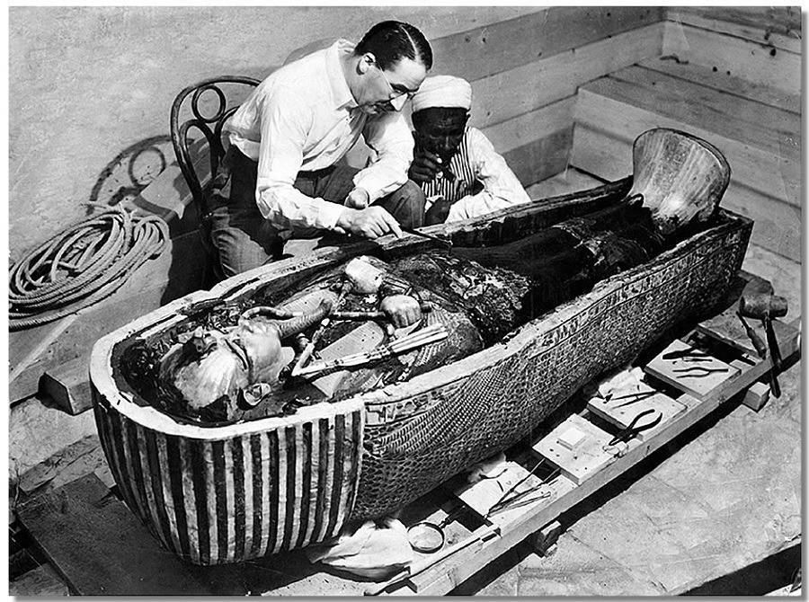

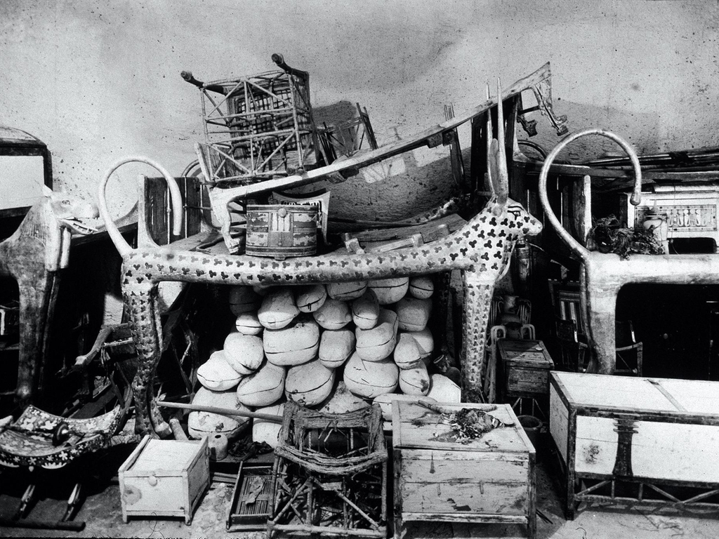

*“… As my eyes grew accustomed to the light, details of the room within emerged slowly from the mist, strange animals, statues, and gold – everywhere the glint of gold. For the moment – an eternity it must have seemed to others standing by – I was struck dumb with amazement, and when Lord Carnarvon, unable to stand the suspense any longer, inquired anxiously, ‘Can you see anything?’ it was all I could do to get out the words, ‘Yes, wonderful things.”* - Howard Carter